Experiment 12: photosensitive lamp experiment

Upon completion of the above experiments, we should have some understanding of the application of Arduino, in the basic digital input and output and analog input and PWM generation are mastered, we can begin some of the application of the sensor. Photosensitive resistor photovaristor called light perception in resistance, is made of using semiconductor photoelectric effect a resistance value with the incident light intensity and change the resistor; incident light intensity, reducing resistance, weak light incident, resistance increases. Photosensitive resistors are generally used for optical measurement, light control and photoelectric conversion (the light variation is converted to electrical variations).
The photosensitive resistor can be widely used in various optical circuit, such as lighting control, regulation and other occasions, can also be used for the light switch.
In this experiment, we first carry out the use of a relatively simple photosensitive resistance test. Photosensitive resistance since it is can according to changes in light intensity resistance element, natural need to simulate the port to read analog value. This experiment can reference PWM interface experiment, the potentiometer for photosensitive resistance when the light intensity and the brightness of the LED lights will have corresponding change.
The following is the required components：
Photosensitive resistor *1

The red line M5 LED*1

10K line resistance *1

220 ohm line resistance *1

Bread board *1

Bread board jumper *1 tie
According to the following schematic connection circuit.
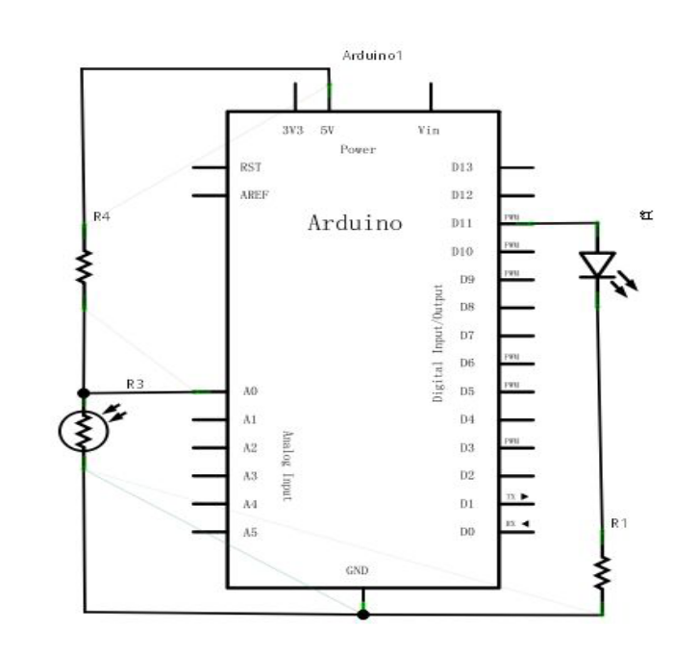
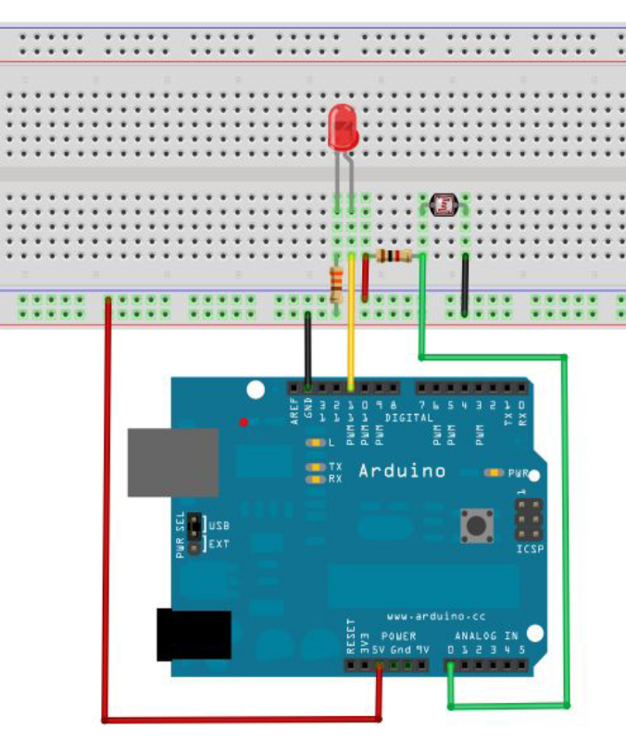
Connected to the program can be written, the experimental program and the PWM test program is similar to the PWM value in the value of the assignment, according to our current circuit slightly modified (modified part see reference to source program).
Reference source program：
int potpin=0;//Define the analog interface 0 connect the photosensitive resistance
int ledpin=11;//Define digital interface 11 output PWM adjust LED brightness
int val=0;//Defined variable val
void setup()
{
pinMode(ledpin,OUTPUT);//Define digital interface 11 for output
Serial.begin(9600);//Set the baud rate to 9600
}
void loop()
{
val=analogRead(potpin);//Read the sensor's analog values and assign to val
Serial.println(val);//Display Val variable value
analogWrite(ledpin,val);// Turn on the LED and set the brightness (the maximum value of the PWM output is 255)
delay(10);//Delay 0.01 seconds
}
Here we return sensor values divided by 4. The reason is that the analog input analogRead () function returns the value of the range is 0 to 1023, and simulation output analogwrite () function of the output value range is 0 to 255. Downloaded program and try to change the intensity of the environment where the photosensitive resistance can see our lights there are corresponding changes. In the daily life of photosensitive resistance application is very extensive of, usage is also a lot of, we can

According to the experimental analogy, make interactive works better.

